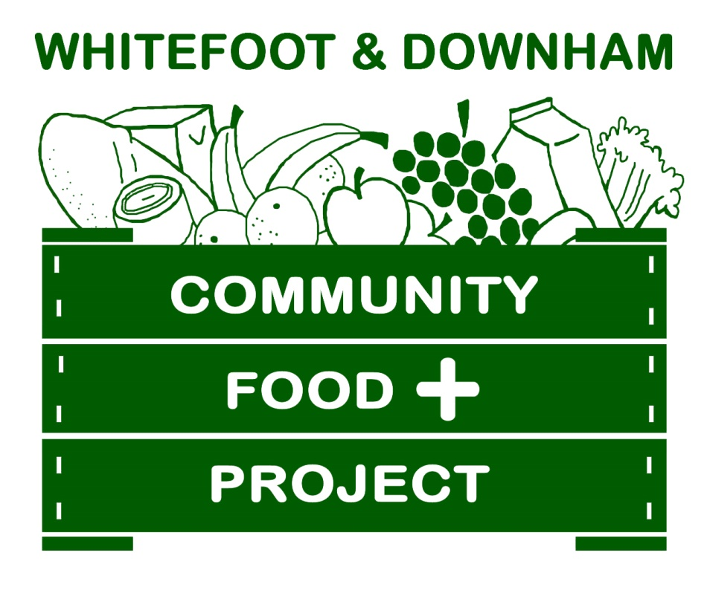
Whitefoot & Downham
Community Food + Project
Form 1 – Part 1

Initial referral Self-referral Re-referral (ISR Form)
(Please circle the one that applies)

To be completed by the referrer for the person requiring food and community support.
The applicant will need to bring this completed form with them to the project, please keep a copy for your records.

If this is a self –referral, please complete areas with Asterix *

*Date

*Name

*Address | Post Code
*Tel no.

*Mobile no.

*Email address
*Name of dependents

*Age of dependants

Have you assessed this visitor for food support? Yes No

What proof of ID has been seen?

*Please confirm proof and circle or tick the reasons that apply:

Benefit changes or delay Money management/debt
No recourse to public funds

Other, please state______________________________________________________

What support is currently being offered to this person and/or their family?

Have you referred them to other organisation(s) for support? Yes No
If Yes, who?

*Is this the first visit to a food bank Inc. for support? Yes No
If No please give details of previous support

*How many weeks will food support be needed? (Please circle below)

6 times 9 times 12 times
other________________
*Within this time the visitor is going to access/attend:-(these will match Areas of Concerns/Personal Goals in part two)
1)

2)

3)

*To the best of my knowledge the information I have given is a true and accurate account

Visitors Signature ________________________________________Date ________________________

*Please state ethnicity?
Please tell us about you and your organisation (if WDCFplus please state)

Name of organisation

Your name

Your telephone number

Your email

Whitefoot & Downham Community Food + Project
Whitefoot Lane Christian Centre, 480 Whitefoot Lane, Downham BR1 5SF
Telephone: 020 8698 7945, MB: 07745 258 841 (Friday only)
Email: info@wdcfplus.org.uk Website: www.wdcfplus.org.uk
Open 7:00pm-8:30pm every Thursday

Whitefoot & Downham Community Food + Project is a voluntary organisation that relies on donations. If you would like to donate to the project please contact us, as any donation is gratefully received

For WDCFplus use only Date seen at the Project _______________________

Visitors Number____________________

Your Name ______________________________________________________________

Your Signature ___________________________________________________________

